Week 3
Simple Applets

- Applets are designed to run in your web browser.
- They are downloaded as a result of your browser seeing an applet tag in your html page.
- There are a series of routines (we call them methods in Java) that are known by the browser. These methods are called automatically according to the following rules:

Here is an applet program, along with the output it produces. We will spend the rest of the period discussing how this program works.
This program solves the identical problem using Swing components
package comparisonswing;
/* <p>Title: ComparisonSwing </p>
* <p>Description: Compares 2 numbers</p>
* <p>Copyright: Copyright Coach (c) 2003</p>
* <p>Company: Coach's Corporation</p>
* @author Coach
*/
import java.awt.*;
import java.awt.event.*;
import javax.swing.*;

public class ComparisonSwing extends JApplet implements ActionListener{
JLabel prompt1;
JTextField input1;
JLabel prompt2;
JTextField input2;
int number1, number2;
JTextArea resultField;

// setup the graphical user interface components and initialize variables
public void init()
{
Container container = getContentPane();
container.setLayout(new FlowLayout());

prompt1 = new JLabel("Enter an integer");
container.add(prompt1);

input1 = new JTextField(10);
container.add(input1);

prompt2 = new JLabel("Enter an integer and press Enter");
container.add(prompt2);

input2 = new JTextField(10);
input2.addActionListener(this);
container.add(input2);

resultField = new JTextArea();
container.add(resultField);
}

// process user's action on the input2 text field
public void actionPerformed(ActionEvent e)
{
number1 = Integer.parseInt( input1.getText() );
number2 = Integer.parseInt( input2.getText() );
resultField.setText("The comparison results are:" + "\n");
if (number1 == number2)
resultField.append(number1 + " == " + number2 + "\n");

if (number1 != number2)
resultField.append(number1 + " != " + number2 + "\n");

if (number1 < number2)
resultField.append(number1 + " < " + number2 + "\n");

if (number1 > number2)
resultField.append(number1 + " > " + number2 + "\n");

if (number1 <= number2)
resultField.append(number1 + " <= " + number2 + "\n");

if (number1 >= number2)
resultField.append(number1 + " >= " + number2 + "\n");
}
}

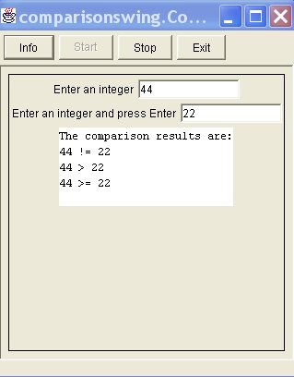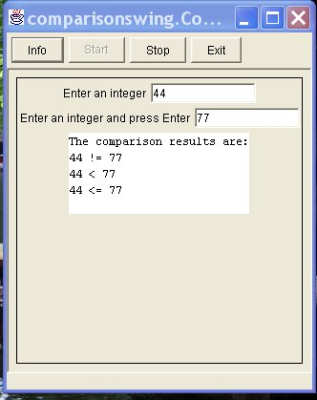

Your 4th Assignment:

You may use either interactive techniques (as demonstrated by the two examples above, to solve the following problem. Technique one uses TextFields, with a paint routine. Technique two uses swing components, with no paint routine.

