Week 2

Constants - A values that is fixed, explicitly stated, does not change:

tax = 12 * .06;

but the tax changes throughout our code

final float SALESTAX = 0.0725;

tax = 12 * SALESTAX;

Variables - Name for a memory location:

Data_Type Variable_Name { = value} ;

byte -128 to 127
short -32,768 to 32,767
int -2,147,483,648 to 2,147,483,647
long Huge
float -3.402823e38 to 3.402823e38
double -1.79769313486232e308 to 1.79769313486232e308
char Symbols used in text (8 bits)
boolean true or false

Operator Precedence Chart

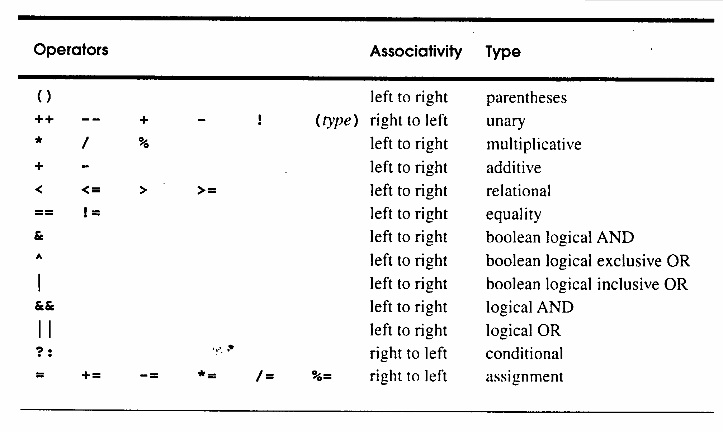

You may use this chart during quizzes and exams.
// Demonstrate the % operator
class Modulus {
public static void main(String args[ ]) {
int x = 42;
System.out.println(“x mod 10 “ + x%10);
}
}

Output:
x mod 10 = 2
The ++ and -- operators
class IncDec { // Example 1
public static void main(String args[ ]) {
int a = 1;
int b = 2;
int c;
int d;

c = ++b;
d = a++;
c++;
System.out.println(“a=” + a);
System.out.println(“b=” + b);
System.out.println(“c=” + c);
System.out.println(“d=” + d);
}
}
What is the output generated by this program?
// Example 2
int a=4, b=9, c, d, e;
c = ++a;
d = b++;
e = ++b;
What is the effect?

// Example 3
int num = 10;
How does (num++ = = num) evaluate? ___________

(num = = num++) evaluate? ___________

(++num = = num) evaluate? ___________

(num = = ++num) evaluate? ___________
Conditional Expression

Here’s a simple if statement (Note: I’ll discuss if statements in detail next week) that will assign the largest value contained in the variables a & b, into the variable max.

if (a>b)
max = a;
else
max = b;

The conditional expression equivalent to this statement is:

max = (a>b) ? a : b;

or

(a>b) ? max = a : max = b;

Blocks and Scope Rules
- Global Variables
- Local Variables
- Name Precedence
