Chapter 15

Graphics in Java

The Abstract Window Toolkit (AWT) class was introduced at the beginning of the semester because it provides support for applets. The AWT contains numerous classes and methods that allow you to create and manage windows. A full description of the AWT could easily consume the entire semester. Therefore, it is not possible to describe in detail every method, instance variable, or class here. The best I can do is to expose you to some of the most fundamental components that enable graphics generation in Java.

The AWT classes are contained in the java.awt package. The following table shows these classes. We will be discussing these classes during the remaining portion of this semester.

Class | Description
BorderLayout | The border layout manager (uses five components: North, South, East, West & Center)
Button | Creates a push button control.
Canvas | A blank, semantics-free window.
CardLayout | The card layout manager which emulates index cards (only the one on top shows).
Checkbox | Creates a check box control.
CheckboxGroup | Creates a group of check box controls.
Choice | Creates a pop-up list.
Color | Manages colors in a portable, platform-independent fashion.
Component | An abstract superclass for various AWT components
Container | An abstract subclass of Component that can hold other components
Dialog | Creates a dialog window.
Dimension | Specifies the dimensions of an object (width is stored in width, height store in height)
Event | Encapsulates events.
FileDialog | Creates a window from which a file can be selected.
FlowLayout | The flow layout manager. Flow layout positions components left to right, top to bottom.
Font | Encapsulates a type font.
FontMetrics | Encapsulates various info related to a font (useful when displaying text in a window).
Frame | Creates a standard window that has a title bar, resize corners, and a menu bar.
Graphics | Encapsulates the graphics context enabling output to be displayed in a window.
GridBagConstraints | Defines various constraints relating to the GridBagLayout class.
GridBagLayout | The grid bag layout manager subject to constraints specified by GridBagConstraints.
GridLayout | The grid layout manager. Grid layout displays components in a two-dimensional grid.
Image | Encapsulates graphical images.
Insets | Encapsulates the borders of a container.
Label | Creates a label that displays a string.
List | Creates a list from which the user can choose (similar to the standard windows list box)
MediaTracker | Manages media objects.
Menu | Creates a pull-down menu.
MenuBar | Creates a menu bar.
MenuComponent | An abstract class implemented by various menu classes.
MenuItem | Creates a menu item.
Panel | The simplest concrete subclass of Container.
Point | Encapsulates a Cartesian coordinate pair, stored in x and y.
Polygon | Encapsulates a polygon.
Rectangle | Encapsulates a rectangle.
Scrollbar | Creates a scroll bar control.
TextArea | Creates a multiline edit control.
TextComponent | A superclass for TextArea and TextField.
TextField | Creates a single-line edit control.
Toolkit | Abstract class implemented by the AWT
Window | Creates a window with no frame, no menu bar, and no title.

Working with Graphics

The AWT support a rich assortment of graphics methods. All graphics are drawn relative to a window. This can be the main window of an applet, a child window of an applet, or a stand-alone application window. The origin of each window is at the top left corner and is 0,0. Coordinates are specified in pixels. All output to a window takes place through a graphics context. A graphics context enables drawing on the screen in Java. A Graphics object manages a graphics context by controlling how information is drawn. A graphics context is encapsulated by the Graphics class and is obtained in two ways:
- It is passed to an applet when one of its various methods, such as paint( ) or update( ) is called.
- It is returned by the getGraphics( ) method.

Though the following examples demonstrate graphics in a main applet window, the same techniques apply to any other window.

The Graphics class defines a number of drawing functions. Each shape can be drawn edge-only or filled. Objects are drawn and filled in the currently selected graphics color, which is black by default. When a graphics object is drawn that exceeds the dimensions of the window, output is automatically clipped. Let's take a look at several of the drawing methods.

Drawing Lines

Lines are drawn by the means of the drawLine( ) method, shown here:

void drawLine(int startX, int startY, int endX, int endY)

drawLine( ) displays a line in the current drawing color that begins at startX, startY and ends at endX, endY.

// Draw lines
import java.awt.*;
import java.applet.*;
/*
<applet code="Lines" width=300 height=200>
</applet>
*/
public class Lines extends Applet {
public void paint (Graphics g) {
g.drawLine(0, 0, 100, 100);
g.drawLine(0, 100, 100, 0);
g.drawLine(40, 25, 250, 180);
g.drawLine(75, 90, 400, 400);
g.drawLine(20, 150, 400, 40);
g.drawLine(5, 290, 80, 19);
}
} // Sample output from this program is shown here:
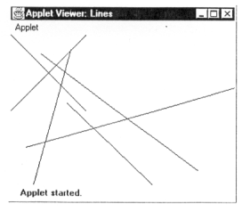
Drawing Rectangles

The drawRect( ) and filRect( ) methods display an outlines and filled rectangle, respectively. They are shown here:

void drawRect(int top, int left, int width, int height)

void fillRect(int top, int left, int width, int height)

The upper-left corner of the rectangle is at top, left. The dimensions of the rectangle are specified by width and height.

To draw a rounded rectangle, use drawRoundRect( ) or fillRoundRect( ), both are shown here:
void drawRoundRect (int top, int left, int width, int height,
int xDiam, int yDiam)
void fillRoundRect (int top, int left, int width, int height,
int xDiam, int yDiam)
A rounded rectangle has rounded corners. The upper-left corner of the rectangle is at top, left. The dimensions of the rectangle are specified by width, and height. The diameter of the rounding arc along the X axis is specified by xDiam. The diameter of the rounding arc along the Y axis is specified by yDiam. The following applet draws several rectangles:

// Draw rectangles
import java.awt.*;
import java.applet.*;
/*
<applet code="Rectangles" width=300 height=200>
</applet>
*/

public class Rectangles extends Applet {
public void paint(Graphics g) {
g.drawRect(10, 10, 60, 50);
g.fillRect(100, 10, 60, 50);
g.drawRoundRect(190, 10, 60, 50, 15, 15);
g.fillRoundRect(70, 90, 140, 100, 30, 40);
}
}

Sample output from this program is shown here:

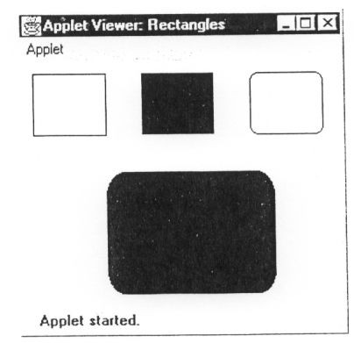
Drawing Ellipses and Circles

To draw an ellipse, use drawOval( ). To fill an ellipse, use fillOval( ). These methods are shown here:
void drawOval(int top, int left, int width, int height)
void fillOval(int top, int left, int width, int height)

The ellipse is drawn within a bounding rectangle whose upper-left corner is specified by top, left and whose width and height are specified by width and height. To draw a circle, specify a square as the bounding rectangle. The following program draws several ellipses:

// Draw Ellipses
import java.awt.*;
import java.applet.*;
/*
<applet code="Ellipses" width=300 height=200>
</applet>
*/

public class Ellipses extends Applet {
public void paint(Graphics g) {
g.drawOval (10, 10, 50, 50);
g.fillOval (100, 10, 75, 50);
g.drawOval (190, 10, 90, 30);
g.fillOval (70, 90, 140, 100);
}
}

Sample output from this program is shown here:
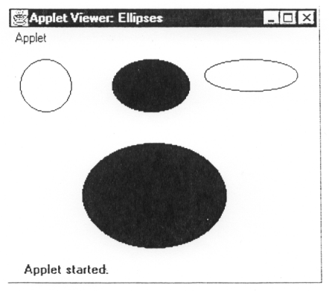
Drawing Arcs

Arcs can be drawn with drawArc( ) and fillArc( ), shown here:

void drawArc(int top, int left, int width, int height, int startAngle,
int sweepAngle)

void fillArc(int top, int left, int width, int height, int startAngle,
int sweepAngle

The arc is bounded by the rectangle whose upper-left corner is specified by top, left and whose width and height are specified by width and height. The arc is drawn from startAngle through the angular distance specified by sweepAngle. Angles are specified in degrees. Zero degrees is on the horizontal, at the 3 o'clock position. The arc is drawn counterclockwise if sweepAngle is positive, and clockwise if sweepAngle is negative. Therefore, to draw an arc from 12:00 to 6:00, the start angle would be 90, and the sweep angle, 180.

The following applet draws several arcs:
// Draw Arcs
import java.awt.*;
import java.applet.*;
/*
<applet code="Arcs" width=300 height=200>
</applet>
*/

public class Arcs extends Applet {
public void paint(Graphics g) {
g.drawArc (10, 40, 70, 70, 0, 75);
g.fillArc (100, 40, 70, 70, 0, 75);
g.drawArc (10, 100, 70, 80, 0, 175);
g.fillArc (100, 100, 70, 90, 0, 270);
g.drawArc (200, 80, 80, 80, 0, 180);
}
}

Sample output from this program is shown here:
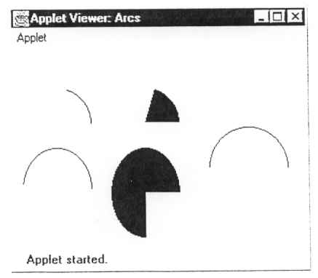
Drawing Polygons

It is possible to draw arbitrarily shaped figures using drawPolygon( ) and fillPolygon( ) shown here:

void drawPolygon(int x[ ], int y[ ], int numPoints)

void fillPolygon(int x[ ], int y[ ], int numPoints)

The polygon's endpoints are specified by the coordinate pairs contained within the x and y arrays. The number of points defined by x and y is specified by numPoints. There are alternative forms of these methods in which the polygon is specified by a Polygon object.

The following applet draws an hourglass shape:

// Draw Polygon
import java.awt.*;
import java.applet.*;
/*
<applet code="HourGlass" width=230 height=210>
</applet>
*/

public class HourGlass extends Applet {
public void paint(Graphics g) {
int xpoints[ ] = {30, 200, 30, 200, 30};
int ypoints[ ] = {30, 30, 200, 200, 30};
int num = 5;
g.drawPolygon(xpoints, ypoints, num);
}
}

Sample output from this program is shown here:
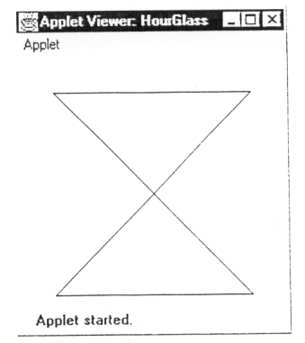
Sizing Graphics

Often, you will want to size a graphics object to fit the current size of the window in which it is drawn. To do so, first call size( ) on the window object. It is shown here: Dimension size( )
It returns the dimensions of the window encapsulated within a Dimension object. Once you have the current size of the window, you can scale your graphical output accordingly.

To demonstrate this technique, here is an applet that will start as a 200x200 pixel square, and grow by 25 pixels in width and height with each mouse click until the applet gets larger than 500x500. At that point, the next click will return it to 200x200 and the process starts over. Within the window, a rectangle is drawn so that it fills the window. This applet uses the mouseUp( ) event method (to be discussed immediately after the midterm).

// Resizing output to fit the current size of a window.
import java.applet.*;
import java.awt.*;
/*
<applet code="ResizeMe" width=200 height=200>
</applet>
*/

public class ResizeMe extends Applet {
final int inc = 25;
int max = 500;
int min = 200;
Dimension d;

public void paint (Graphics g) {
d = size( );
g.drawLine(0, 0, d.width-1, d.height-1);
g.drawLine(0, d.height-1, d.width-1, 0);
g.drawRect(0, 0, d.width-1, d.height-1);
}

public boolean mouseUp(java.awt.Event evt, int x, int y) {
int w = (d.width + inc) > max?min : (d.width + inc);
int h= (d.height + inc) > max?min : (d.height + inc);
resize(w, h);
return true;
}
}
Working with Color

Java supports color in a portable, device-independent fashion. The AWT color system allows you to specify any color you want. It then finds the best match for that color, given the limits of the display hardware currently executing your program or applet. Thus, your code does not need to be concerned with the differences in the way color is supported by various hardware devices. Color is encapsulated by the Color class.

Color defines several constants (for example Color.black, Color.blue etc.) to specify a number of common colors. You can also create your own colors, using one of the color constructors, shown here:
Color(int red, int green, int blue)
or
Color(float red, float green, float blue)

The 1st constructor takes three integers that specify the color as a mix of red, green, and blue. These values must be between 0 and 255, as in this example:
new Color(255, 100, 100) // light red.

The 2nd color constructor takes three float values (between 0.0 and 1.0) that specify the relative mix of red, green, and blue.

Once you have created a color, you can use it to set the foreground and/or background color by using the setForeground( ) and setBackground( ) methods.

The Color class defines several methods that help manipulate colors. You can obtain the red, green, and blue components of a color independently using getRed( ), getGreen( ), and getBlue( ), shown here:
int getRed( )
int getGreen( )
int getBlue( )
Each of these methods returns the RGB color component found in the invoking Color object into the lower 8 bits of an integer.

By default, graphics objects are drawn in the current foreground color. You can change this color by calling the Graphics method setColor( ):
void setColor(Color newColor)
Here, newColor specifies the new drawing color. You can obtain the current color by calling getColor( ), shown here:
Color getColor( )
// Demonstrate color.
import java.awt.*;
import java.applet.*;
/*
<applet code="ColorDemo" width=300 height=200>
</applet>
*/
public class ColorDemo extends Applet {
// draw lines
public void paint(Graphics g) {
Color c1 = new Color(255, 100, 100);
Color c2 = new Color(100, 255, 100);
Color c3 = new Color(100, 100, 255);

g.setColor(c1);
g.drawLine(0, 0, 100, 100);
g.drawLine(0, 100, 100, 0);

g.setColor(c2);
g.drawLine(40, 25, 250, 180);
g.drawLine(75, 90, 400, 400);

g.setColor(c3);
g.drawLine(20, 150, 400, 40);
g.drawLine(5, 290, 80, 19);

g.setColor(Color.red);
g.drawOval(10, 10, 50, 50);
g.fillOval(70, 90, 140, 100);

g.setColor(Color.blue);
g.drawOval(190, 10, 90, 30);
g.drawRect(10, 10, 60, 50);

g.setColor(Color.blue);
g.drawOval(190, 10, 90, 30);
g.drawRect(10, 10, 60, 50);

g.setColor(Color.cyan);
g.fillRect(100, 10, 60, 50);
g.drawRoundRect(190, 10, 60, 50, 15, 15);
}
}
Foreground & Background Colors
To set the background color of an applet's window, use setBackground( ). To set the foreground color (the color in which text is shown, for example), use setForeground( ). These methods are defined by Component, and they have the following general forms:
void setBackground(Color newColor)
void setForeground(Color newColor)
The following sets the background to green and foreground to red:
setBackground(Color.green);
setForeground(Color.red);

A good place to set the foreground and background colors is in the init( ) method. Of course, you can change these colors as often as necessary during the execution of your applet. The default foreground color is black. The default background color is light gray.
Assignment for Chapter 15

Write an applet that simulates a screen saver. The applet should randomly draw lines using method drawLine of class Graphics. After drawing 100 lines, the applet should clear itself and start drawing lines again. To allow the program to draw continuously, place a call to repaint as the last line in the method paint.

Some issues for you to consider:
- The update method automatically clears the screen before calling paint. You will need to override this method so that it simply calls paint.
- When you want to erase the screen (i.e., the line counter gets to 100), consider calling super.update.
- You must not have a loop in paint that prints the 100 lines. You must draw a single line in paint, and call repaint, then fall through the bottom of the paint routine.
- You’ll need to pause between each line that’s drawn. There are several ways of doing this. You might use the index to read about a version of repaint that lets you pass a pause time, or you could also look up sleep.

Extra Credit: Draw the individual lines with random colors, changing the background color to a new color for each set of 100 lines.

Update: The repaint method with the millisecond pause is currently not working properly with JBuilder. Currently, the best way to pause uses the following code:

try { Thread.sleep( the amount of milliseconds put here ); }
catch (InterruptedException e) { }

